

MATHEMATICS
Specialist Units 3 & 4

Test 2 – Functions and Sketching Graphs

Semester 1 2019

Section One – Calculator Free

Time allowed for this section
Working time for this section: 24 minutes
Marks available: 24 marks

Material required/recommended for this section

To be provided by the supervisor
This Question/Answer booklet
Formula sheet

To be provided by the student
Standard items: pens, pencils, pencil sharpener, eraser, correction fluid, ruler, highlighters

Special items: Nil

Important note to students
No other items may be used in this section of the assessment. It is your responsibility to ensure that you do not have any unauthorised notes or other items of a non-personal nature in the assessment room. If you have any unauthorised material with you, hand it to the supervisor before reading any further.

- (8 marks: 3, 3, 1, 1)
Let $f\left(x\right)=x^{2}-2\left|x\right|-3$
  - Rewrite $f(x)$ in piecewise form.

  - On the axes below, sketch the graph of $f\left(x\right)=x^{2}-2\left|x\right|-3$.

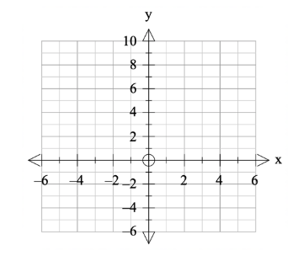

  - Use the sketch to explain why $f(x)$ does not have an inverse function.

  - Suggest an appropriate restriction on the domain for the inverse of $f(x)$ to be a function.

- (6 marks)
Sketch the graph of $f\left(x\right)=-\frac{4(x-3)(x+1)}{x^{2}-2x-8}$ on the axes below.

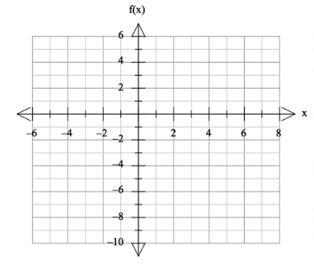

- (3 marks)
Given the graph of $g\left(x\right)$ below, sketch and label clearly $y=\left|g(x)\right|$ on the second axes.

- (7 marks: 3, 1, 3)
Suppose $f\left(x\right)=9-\sqrt{x}$ and $g\left(x\right)=x^{2}+4$.
  - Find $f∘g(x)$ and state its domain and range.

  - Find $g∘f(x)$

  - Find $f∘f(x)$ and state its domain and range.

End of Section One
This page has intentionally been left blank
You may use this space to extend or re-attempt an answer to a question or questions and should you do so then number the question(s) attempted and cross out any previous unwanted working.

